Lesson One (Teacher)
“Introduction to the Atmosphere”

Objective
The atmosphere, air pollution, and meteorology may be fairly new topics for the students, so the first day’s discussions and brief demonstrations provide an opportunity to gauge their incoming knowledge. This will help teachers identify any common misconceptions to address by the end of the curriculum.
A demonstration with ice water and associated discussion will help students review three states of matter—solid, liquid, and gas—and examples of how the transfer of heat energy can cause transitions between these states. Students should then begin to think of the atmosphere around them as a mixture of gases. How do we know that air actually exists—that what surrounds us is not just empty space? Inflating a balloon and discussing how they perceive the air with their senses will help students explore this question. Teachers will also introduce the various measuring tools to the class, explain how they work, and organize students into teams for the measurements.
Students should leave with a sense of wonder about the atmosphere around them and motivated to learn more about its importance. Interesting facts in the “Background Information” section can help the teacher achieve this goal.
Background Information
Matter is anything that takes up space, and is what makes up everything that we see. Solids, liquids and gases are three states of matter. A solid has both a fixed volume and fixed shape. A liquid takes the shape of whatever container that it is in, but has a fixed volume. Gases, however, do not have a fixed volume—they spread out to take up space, like in a balloon.
Students should recognize examples of transitions between states of matter and the role of heat energy in causing them. Adding heat energy can convert a solid to a liquid, or a liquid to a gas. Removing heat energy can turn a gas to a liquid, or a liquid to a solid. The condensation in the ice water demonstration provides a visual example, as the cold glass condenses water vapor (gas) from the air to form liquid water on the outside of the glass.
Air is a fascinating gas. Every breath we take (~1 liter) has 10²² molecules of air! That is about as many stars as exist in the universe. Interestingly, if you could make a box with sides the width of a human hair, it could still have trillions of air molecules inside. However, these air molecules are so small that air appears “invisible” to the naked eye. Air molecules do scatter light, especially at blue wavelengths, which gives the sky its color. Particles suspended in the air can both scatter and absorb light, creating a hazy appearance when the air is polluted (Figure 1).
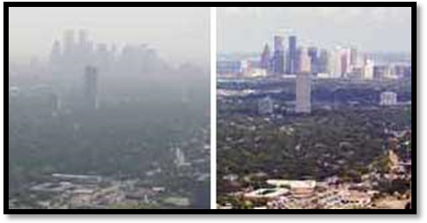
Figure 1. Houston on a hazy day (L) and on a clear day (R)
Credit: http://www.jpl.nasa.gov/news/features.cfm?feature=423

The air around the Earth is called the atmosphere. Viewed from space (Figure 2), we see that the atmosphere is very thin compared to the Earth overall. However, the atmosphere is vitally important to life on Earth. It contains the air that animals breathe and that plants use for photosynthesis; absorbs UV radiation; regulates the planet’s temperature; blocks meteors from crashing onto our surface; and is where weather occurs.
The mass of the atmosphere (about 1.1×10¹⁹ pounds, or 5.1×10¹⁸ kilograms) can best be understood by considering atmospheric pressure, which is the pressure exerted by the weight of the atmosphere above a given point. Atmospheric pressure averages 14.7 psi (pounds per square inch) at sea level. This means that if you drew a square one inch wide and one inch long on the Earth’s surface, the column of air rising above that square into space would weigh 14.7 pounds! The higher you travel in the atmosphere, the lower the density of air, but there is no definite boundary where the atmosphere ends and outer space begins.

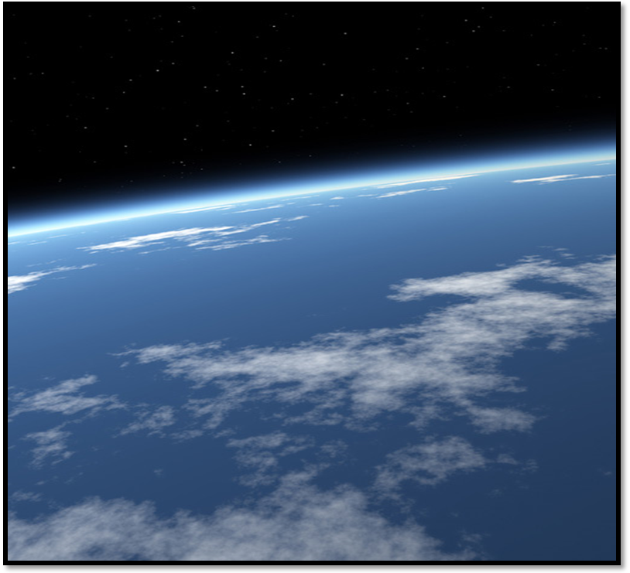

Fig. 2. From space, the atmosphere appears as a thin blue line between Earth and outer space.
Credit: http://www.adventures.com.sg/

Materials (for a class of 25)

- Water glass (1 per class)
- Water (Enough to fill the glass)
- Ice
- 1 Hot plate (if possible)
- Access to Brainpop.com
- Computer
- Balloons (1 per student)

GLOBE instruments (described in GLOBE measurement protocols at www. globe.gov):

- Ozone strips (1 per class)
- Ozone Scanner (1 per class)
- Hygrometer (1 per class)
- Infrared Thermometer (1 per class)
- Cloud Charts (1 per class)
- Wind Vane (1 per class)
- Thermal Glove (1 per class)

Vocabulary

- Matter
- Solid
- Liquid
- Gas
- Air
- Temperature
- Heat Energy
- Thermometer
- Atmosphere
- Molecules
- Atmospheric Pressure

Demonstration: The Three States of Water (Step 2 of Lesson Plan)
This demonstration is geared toward introducing students to three states of matter, and how transfers of heat energy can change the state of matter.
- In a clear glass, put in cold water and ice.
- Condensation should form on the outside of the glass.
- Explain or let your students try to explain what states of matter they see. In this example, the water is a liquid and the ice is a solid. The “wetness” on the outside of the glass is a liquid that forms as the water vapor (gas) from the outside air cools and condenses onto the glass.
- It is strongly recommended that you use a hot plate to demonstrate gas as the third state of matter, and how heat energy can change the state of matter. Heating a pot of water until it begins to steam, you can explain to students that heat energy from the hot plate is converting some of the liquid water into the gas (steam) that is being released.
- Ask students to explain what transfers of heat energy are causing the changes in states of matter that they are observing.


Credit: http://www.acornadvisors.com

Step-by-Step Suggested Lesson Plan
Note: Page numbers listed in the Student Activity column refer to Student worksheets.
Instructor Activity  - Explain the purpose of the curriculum. Let the students know that they will be learning about the Earth’s atmosphere, air pollution, and meteorology.  - Demonstration: The Three States of Water (icewater demonstration on previous page)  - Optional Video: “States of Matter” on Brainpop.com.  - Demonstration: Ask the class to blow up balloons, and ask them what is filling up the space inside.  - Brainstorming: Ask students why they cannot see the air around them. Then, ask them to describe experiences that they have had that demonstrate that air exists. For example, blowing warm air on a mirror (warm air condenses onto cool surface), seeing wind turn a pinwheel or windmill, blowing bubbles underwater, etc.  - Discussion/Brainstorming: Share with students interesting facts from the “Background Information” section about the air and the atmosphere to pique their interest about the atmosphere. Brainstorm with students about why the atmosphere, though so thin, is actually quite important.  - Demonstration: Introduce each measuring tool to the students, and invite questions from the students as they pass around the tools. Let students know how each tool works, and that they will get to use them to measure air pollution and meteorology.  - Ozone strips  - Ozone scanner  - Infrared thermometer gun  - Hygrometer  - Cloud charts  - Wind vane  - Thermal glove | Student Activity  Students observe the demonstration and answer questions (p. 1)  Students watch and take notes  Students participate in balloon activity and learn that air is a gas  Students brainstorm other examples that show air exists and write down examples (top of p. 2)  Students discuss, ask questions, and answer questions at bottom of p. 2.  Students interact with each other and with the teacher as they handle each instrument and learn how each one works in preparation for Lesson Two. Students fill in instrument names and what they measure (p.3)
Expected Outcomes:
- Students are reacquainted with the three states of matter.
- Students seek out examples of how transfers of heat energy can cause the state of matter to change.
- Students identify examples that demonstrate the existence of air and the importance of the atmosphere.
- Though students may not understand exactly how the measuring instruments work, they become familiar with each instrument to help prepare them for the measurements in the following class periods.
- Students should complete Lesson One Journal Activities.

